Continuous Assessment Exam -II
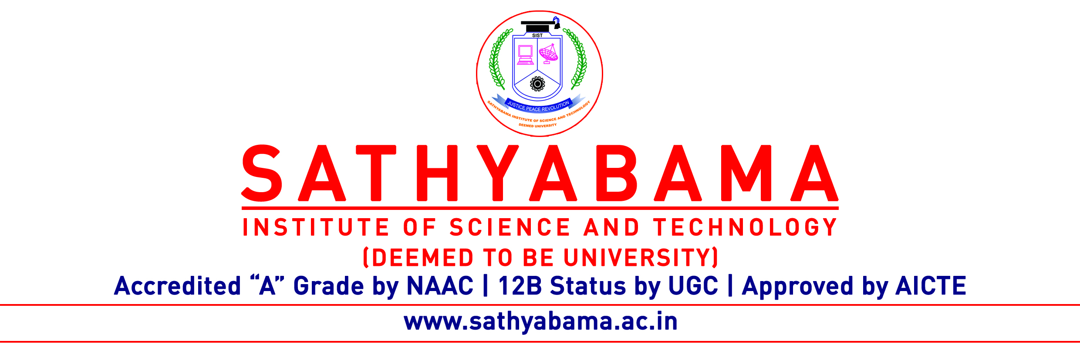
Program : B.E Max. Marks : 30
Course : Network Security Time : 1 Hour
Course Code: SCSA1602 Sem : VI
Batch : 2019-2023 Date :4.4.2022
Part-A Answer ALL the questions (5×2=10)

Q.No | Questions | CO (L)
 | Compare the difference between the public key and private key cryptosystems | CO3
 | Is it possible to use the DES algorithm to generate message authentication code? Justify. | CO3
 | Mention the application of public key cryptography. | CO3
 | What are the requirements for a Hash Function | CO4
 | Define Digital Signature | CO4

Part-B Answer ALL the questions (2×10=20)

Q.No | Questions | CO (L)
 | In a public key system using RSA, you intercept the cipher text C=10 sent to a user with an algorithm description whose public key is e=5, n=35. What is the plain text? Explain the above problem | CO3
 | (OR)
 | Users A and B use the Diffie-Hellman Key exchange technique with a common prime q=71 and a primitive root 𝛼 = 7. If the user A has private key XA=5, what is A’s public key YA?. Justify your answer | CO3

 | What is authentication? Explain the MD5 with neat diagram | CO4
 | (OR)
 | Explain x.509 certificate in detail. What is the cryptographic method used in x.509 certificate | CO4

